E-commerce Data Dictionary

Purpose for Sprint 1
This document describes the tables, fields, calculated columns, and relationships represented in the Task 1 Training e-commerce workbook and the supplied Power BI data-model screenshot. It is intended to support data preparation, model validation, and dashboard interpretation. Field definitions are based on the visible model and the source Data Dictionary; derived fields are identified separately from source fields.

Data Model & Table Relationships
The model contains seven main tables: distribution_centers, events, inventory_items, order_items, orders, products, and users. The model connects customer, order, product, inventory, distribution-center, and website-event data for integrated analysis.
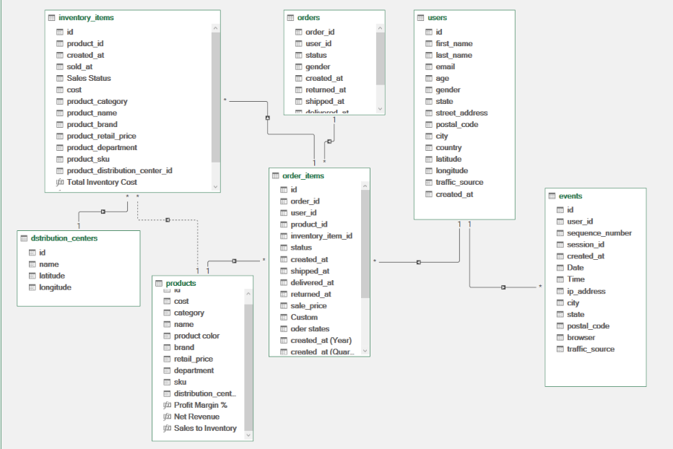
Figure 1. Data model supplied for Task 1 Training.
Use the diagram as the reference for the implemented relationships. Relationship cardinality, active/inactive status, and filter direction should be checked in Power BI before building measures that depend on them.

``1. Distribution Centers
Table Type: Dimension / reference table
Table Description: Stores the locations of the distribution centers associated with product and inventory operations.

Column Definitions
Column | Definition
id | Unique identifier for each distribution center. Primary Key (PK).
name | Name of the distribution center.
latitude | Geographic latitude of the distribution center.
longitude | Geographic longitude of the distribution center; negative values can represent locations west of the Prime Meridian.

Analytical Notes
- The distribution center identifier is used to connect location information with related product or inventory records, depending on the configured relationship.
- Latitude and longitude are geographic coordinates and should be kept numeric.

2. Events
Table Type: Fact table / event log
Table Description: Records website activity and customer interactions. The table can support analysis of traffic sources, browsing activity, and event timing.

Column Definitions
Column | Definition
id | Unique identifier for each recorded event. Primary Key (PK).
user_id | Identifier of the user associated with the event; it may be blank for activity not linked to a known user.
sequence_number | Sequence number recorded for the event. Validate its variation before using it to order events.
session_id | Identifier of the browsing session.
created_at | Original date and time when the event was recorded.
Date | Derived date field visible in the model; document the transformation used to extract the date from created_at.
Time | Derived time field visible in the model; document the transformation used to extract the time from created_at.
ip_address | Technical field containing the visitor's IP address; usually not required for standard business reporting.
city | City associated with the recorded event.
state | State associated with the recorded event.
postal_code | Postal code associated with the recorded event.
browser | Browser recorded for the browsing session.
traffic_source | Traffic source recorded for the event/session; it can differ from the user's original acquisition source.
uri | Page URI visited or recorded for the event.
event_type | Type of website activity recorded by the source data.

Analytical Notes
- Date and Time are derived fields in the model, not original source columns, if they were created during Power Query preparation.
- If uri or event_type contains only one value in the loaded data, keep the field if it is part of the source/model and explain its limited analytical usefulness rather than deleting it automatically.
- Missing user IDs may represent unlinked or guest activity and should be assessed in context.

3. Inventory Items
Table Type: Fact table / inventory-unit level
Table Description: Contains records for individual inventory units, including cost, product descriptors, and inventory dates.

Column Definitions
Column | Definition
id | Unique identifier for each inventory unit. Primary Key (PK).
product_id | Identifier of the related product. Foreign Key (FK) referencing products.id.
created_at | Date and time when the inventory record was created.
sold_at | Date and time when the inventory unit was sold; a blank value may indicate that no sale date is recorded.
Sales Status | Status/category field visible in the model. Confirm the exact rule used to classify inventory as sold or not sold.
cost | Cost associated with the individual inventory unit.
product_category | Product category associated with the inventory unit.
product_name | Name of the associated product.
product_brand | Brand of the associated product.
product_retail_price | Retail/list price associated with the product.
product_department | Department associated with the product.
product_sku | Stock Keeping Unit (SKU) used to identify the product.
product_distribution_center_id | Identifier of the distribution center associated with the inventory record.
Total Inventory Cost | Calculated field visible in the model. Confirm whether it aggregates or derives cost before using it in measures.

Analytical Notes
- Inventory-level costs should be analyzed at inventory-unit granularity to avoid double counting.
- A blank sold_at value should not automatically be treated as zero; interpret it according to the business rule used for Sales Status.
- Product descriptors are repeated in this table and should be checked for consistency with the products table.

4. Order Items
Table Type: Fact table / order-line level
Table Description: Contains item-level records associated with customer orders. It supports analysis of sales, order fulfillment, and returns.

Column Definitions
Column | Definition
id | Unique identifier for each order-item record. Primary Key (PK).
order_id | Identifier of the order containing the item. Foreign Key (FK) referencing orders.order_id.
user_id | Identifier of the customer associated with the order item.
product_id | Identifier of the product associated with the order item. Foreign Key (FK) referencing products.id.
inventory_item_id | Identifier of the inventory unit associated with the order item; used to connect to inventory_items.id where configured.
status | Recorded status of the individual order item.
created_at | Date and time when the order-item record was created.
shipped_at | Date and time when the item was shipped; may be blank if it was not shipped or no date was recorded.
delivered_at | Date and time when the item was delivered; may be blank if it was not delivered or no date was recorded.
returned_at | Date and time when the item was returned, if applicable.
sale_price | Recorded selling price for the order item; use this field for item-level sales calculations when appropriate.
Custom | Custom field visible in the model; its business definition should be documented from the transformation or source logic.
order states | Derived/label field visible in the model; confirm the mapping used from the source status values.
created_at (Year) | Year-level date hierarchy/derived field visible in the model, based on created_at.
created_at (Quarter) | Quarter-level date hierarchy/derived field visible in the model, based on created_at.

Analytical Notes
- Use sale_price for item-level revenue calculations, with the chosen status rules applied consistently.
- Use order-item status for item-level returns; do not rely only on the order-level status.
- Avoid double counting when joining order items to inventory items or orders.

5. Orders
Table Type: Fact table / order level
Table Description: Stores order-header information, including customer references, status, timestamps, and the number of items in each order.

Column Definitions
Column | Definition
order_id | Unique identifier for each order. Primary Key (PK).
user_id | Identifier of the customer who placed the order. Foreign Key (FK) referencing users.id.
status | Recorded order status, such as Cancelled, Complete, Processing, Returned, or Shipped where present in the data.
gender | Gender value recorded for the order, if provided.
created_at | Date and time when the order was created.
returned_at | Date and time associated with the order return, if recorded.
shipped_at | Date and time when the order was shipped.
delivered_at | Date and time when the order was delivered.
num_of_item | Number of items associated with the order.

Analytical Notes
- Order-level status and order-item-level status may differ; select the appropriate grain for each KPI.
- Blank lifecycle timestamps should be interpreted alongside the order status.
- Avoid summing order-level counts after joining to order-item rows unless the measure accounts for the changed granularity.

6. Products
Table Type: Dimension table with calculated analytical fields
Table Description: Contains product attributes used for product classification, pricing, and product-performance analysis.

Column Definitions
Column | Definition
id | Unique identifier for each product. Primary Key (PK).
cost | Recorded cost associated with the product.
category | Product category.
name | Product name.
product color | Product color attribute.
brand | Brand associated with the product.
retail_price | Listed retail price of the product.
department | Department to which the product belongs.
sku | Stock Keeping Unit used to identify the product.
distribution_center_id | Identifier of the associated distribution center; intended to reference distribution_centers.id.
Profit Margin % | Calculated field visible in the model. Confirm the formula and whether the result is a ratio or percentage before interpreting it.
Net Revenue | Calculated field visible in the model. Confirm the business definition and exclusions applied.
Sales to Inventory | Calculated field visible in the model. Confirm the numerator, denominator, and aggregation logic.

Analytical Notes
- retail_price is a listed price and may differ from the actual transaction price recorded in order_items.sale_price.
- Profit Margin %, Net Revenue, and Sales to Inventory are analytical fields rather than original product attributes; document their formulas in the workbook or DAX definitions.
- Validate cost and price values before using them in financial calculations.

7. Users
Table Type: Dimension table
Table Description: Contains customer information for demographic, geographic, acquisition-source, and customer-level analysis.

Column Definitions
Column | Definition
id | Unique identifier for each user. Primary Key (PK).
first_name | Customer's first name.
last_name | Customer's last name.
email | Customer's email address.
age | Customer's recorded age.
gender | Customer's recorded gender.
state | State associated with the customer's address.
street_address | Customer's recorded street address.
postal_code | Postal code associated with the customer's address.
city | City associated with the customer's address.
country | Country associated with the customer's address.
latitude | Geographic latitude associated with the customer's location.
longitude | Geographic longitude associated with the customer's location.
traffic_source | Recorded source through which the user originally arrived at the website.
created_at | Date and time when the user account was created.

Analytical Notes
- Customer fields can support demographic, geographic, and acquisition-source analysis.
- The user's original traffic_source may differ from the traffic source recorded for a later website event.
- Exclude personal identifiers such as email and street address from published reports unless they are specifically needed.

Relationships
The seven main source tables are distribution_centers, events, inventory_items, order_items, orders, products, and users. The model screenshot should be treated as the primary reference for the implemented relationship layout.
- users.id → orders.user_id: links orders to the customer who placed each order.
- users.id → events.user_id: links website events to the associated user when a user ID is available.
- orders.order_id → order_items.order_id: links each order to its order-item records.
- products.id → order_items.product_id: links products to order items.
- products.id → inventory_items.product_id: links products to inventory records.
- distribution_centers.id → products.distribution_center_id: links products to their associated distribution center, if this relationship is active in the model.
- inventory_items.id → order_items.inventory_item_id: links order items to their corresponding inventory units where configured.
Note: Verify cardinality (typically one-to-many where keys are unique), active/inactive status, and cross-filter direction in Power BI. The screenshot includes derived fields and may show relationship lines differently from the source dictionary; use the actual Power BI model to confirm the final configuration.

Data Model Structure
The model combines transactional/event tables with descriptive tables. The exact classification below is based on the role each table plays in the supplied model; some tables can function as fact-like tables for one analysis and as supporting tables for another.

Fact / Transaction Tables
- order_items: order-line records for item-level sales, fulfillment, and returns.
- orders: order-header records for order counts, order status, and order lifecycle.
- inventory_items: individual inventory-unit records, costs, and sale dates.
- events: website activity records for behavioral and traffic analysis.

Dimension / Reference Tables
- users: customer attributes and acquisition source.
- products: product descriptions, category, department, brand, and prices.
- distribution_centers: distribution-center names and geographic coordinates.

Calculated / Derived Fields
The supplied model shows derived or analytical fields including Date and Time in events; Sales Status and Total Inventory Cost in inventory_items; Custom, order states, and created_at date levels in order_items; and Profit Margin %, Net Revenue, and Sales to Inventory in products. Their exact formulas should be documented from the Power Query steps, calculated-column expressions, or measures used in the workbook. Do not assume a formula solely from the displayed field name.

Business Rules & Data Quality Notes

1. Sales and Order Status
- Define which statuses qualify as sales before calculating revenue; do not assume all orders or order items are completed sales.
- Treat cancelled and returned records according to the agreed reporting logic, and distinguish order-level status from item-level status.
- Use order_items.sale_price for actual item-level selling price where applicable; retail_price is the listed product price.
- Calculate metrics at the correct grain to avoid double counting orders, items, inventory units, or customers.

2. Missing Values
- Missing descriptive text may be labeled Unknown when useful for reporting, but preserve the original values where data lineage matters.
- Missing numeric values should remain blank unless a documented business rule justifies replacing them.
- Missing dates can indicate that an event such as shipment, delivery, or sale has not occurred or has not been recorded.
- Missing foreign keys should be investigated when they prevent records from being reliably linked.

3. Calculated Fields and Consistency
- Document the formula and data type of each calculated field, including Sales Status, Total Inventory Cost, Profit Margin %, Net Revenue, and Sales to Inventory.
- Validate date/time transformations and confirm that Year and Quarter fields are derived from the intended date column.
- Check the relationship configuration in Power BI before relying on cross-table filters in visuals or measures.
- Keep field names consistent with the model where possible; explain any renamed columns so the source-to-report mapping remains clear.

